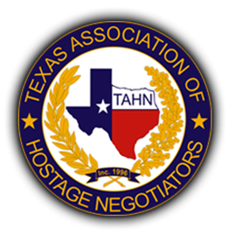

The Texas Association of Hostage Negotiators will be hosting their 33rd Annual TAHN Training Conference in the historical and beautiful Waco, Texas. We anticipate record numbers of attendees and appreciate the support provided to our organization. Hostage negotiators are a specialized unit within law enforcement which uses tactics to prevent injury and/or death in standoffs, suicide attempts, hostage situations and kidnappings.
The conference will be November 2-6, 2026 at the Waco Convention Center 100 Washington Ave.
For the annual conference, there are several opportunities for you to donate items for raffle/ door prizes, sponsor events or provide cash donations. Our goal is to provide the best possible training to ensure we equip the negotiators with the best training possible to increase successful negotiations.
We plan to host a social for all the participants. You are also welcome to sponsor events, refreshments, etc.
You can donate directly to any representative of the TAHN board, online, or by mail.
TAHN PO Box 1020 Rowlett, Tx 75030.

In Kind Regards,

Texas Association of Hostage Negotiators

Cash donation: _______________
Raffle/Door Prize: ______________________________________________
Sponsorship of Event: ___________________________________________

This Corporation is organized and operated as a non-profit corporation under the laws of the State of Texas for the benefit of hostage/crisis negotiation professionals, promotion of the profession, Training and Education of individuals involved and related to hostage/crisis negotiations and other similar non-profit purposes. Any income received shall be applied only to the non-profit purposes and objectives of the corporation and no part of the income shall insure to the benefit of any officer or director of the Corporation. It shall operate strictly within the requirements of section 501 (c) (3) of the Internal Revenue Code and the laws of Texas governing such corporations. Should this Corporation ever dissolve, its assets shall be turned over to a similarly organized entity exempt under section 501 (C) (3) of the Internal Revenue Code.
TAHN Tax ID Number is: 75-2710751

